**CSE523 Machine Learning**

**Prof. Mehul Raval**

**Product Classification using their Ingredient**

**Week 6 Report**

| **Name** | **Enrolment Number** |
| --- | --- |
| Aharnish Pithva | AU2040022 |
| Jevin Jivani | AU2040051 |
| Astha Bhalodiya | AU2040067 |
| Yug Patel | AU2040181 |

**1) Tasks Performed in the week.**

During this week, we incorporated the Quadratic Discriminant Analysis (QDA) algorithm into our classification problem.

We conducted two runs of the algorithm, one without using Principal Component Analysis (PCA) and another with PCA, in order to analyze and compare the differences in the outcomes.

**2) Outcomes of the tasks performed.**

Results observed before PCA implementation:

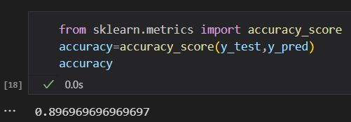

Results observed after PCA implementation:

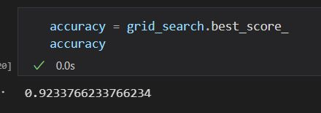

This shows that PCA gives the best results for Dimensionality Reduction as it reduces the runtime and improves the accuracy of the model.

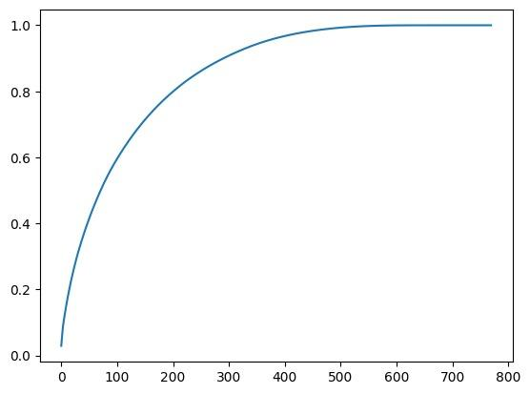

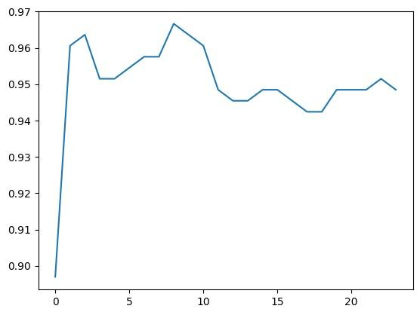

This graph shows the change in accuracy based on the number of features.

**3) Tasks to be performed in the upcoming week.**

Our intention is to incorporate various algorithms into our analysis pipeline once we have completed the implementation of Principal Component Analysis (PCA) on our dataset. This indicates that PCA will be the initial step in our data analysis process, followed by the integration of additional algorithms for further analysis or modeling. By utilizing PCA as a preliminary step, we aim to reduce the dimensionality of our dataset and extract meaningful features or patterns from the data. Subsequently, we plan to leverage the outcomes of PCA to apply different algorithms that are suited to our specific analysis objectives. This approach allows us to effectively process and interpret the data, potentially leading to more accurate and insightful results.